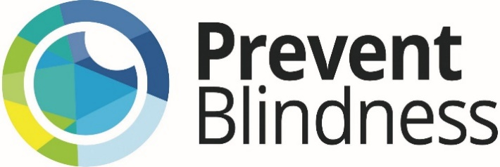

2021 Prevent Blindness Rising Visionary Award

Application Information

Prevent Blindness Rising Visionary Award:
The Prevent Blindness Rising Visionary Award is presented annually to an optometry student or resident, ophthalmology resident, primary health care, nursing, or other health professional student or resident in the United States who has the best essay based on the 2021 Focus on Eye Health National Summit theme: Our Changing Vision. This esteemed award consists of formal acknowledgement and a commemorative plaque to be presented at the Focus on Eye Health National Summit virtually on July 14 or 15th, 2021. It further comes with an invitation to present this work as a speaker at the Summit. Information on previous recipients of the Prevent Blindness Rising Visionary Award can be found here.

Application Criteria:
An optometry student or resident, ophthalmology resident, primary health care, nursing, or other health professional student or resident in the United States who has the best essay based on a question related to the 2021 Focus on Eye Health National Summit theme: Our Changing Vision. If awarded, the awardee must be available to present virtually at the 2021 Focus on Eye Health National Summit on July 14th or 15th, 2021 to receive the award.

Submission:
- Application Cover Sheet
- Essay: 500-word essay answering a question based on the 2021 Focus on Eye Health National Summit theme: Our Changing Vision.
QUESTION: What significant change can be made to improve equity in vision and eye health in the U.S.? Describe your reasoning.
- What is the significant change? (100 words)
- How will it improve equity in vision and eye health in the U.S.? (250 words)
- Describe the systems or processes that will need to change to accomplish it. (150 words)
- Curriculum Vitae and Personal Statement: Submit a Curriculum Vitae no more than 1 page containing baccalaureate and higher educational preparation, positions and employment, other experience and professional memberships, and honors. Please include a 200-word personal statement which describes the relevant academic, experiential and leadership training that prepared you for this essay. Click here for an example.
- Letters of Recommendation: Up to two recent letters of recommendation including how they know the applicant and for how long (two-page maximum for each letter)
- Please note: Submissions not adhering to the above submission guidelines (page limits, word count, etc.) will not be reviewed.

About Prevent Blindness and the Focus on Eye Health Summit
Founded in 1908, Prevent Blindness is the nation's leading volunteer eye health and safety organization dedicated to fighting blindness and saving sight. Focused on promoting a continuum of vision care, Prevent Blindness touches the lives of millions of people each year through public and professional education, advocacy, certified vision screening and training, community and patient service programs and research.

The Focus on Eye Health National Summit elevates the national dialogue among diverse stakeholder groups around vision and significant population health issues such as surveillance, equity, prevention messaging, service integration, program development, and dissemination of best practices. The Summit allows its participants to develop new collaborations, integrate new vision health messages and procedures into their outreach, and improve lines of communication with internal and external partners. On July 14-15, 2021, Prevent Blindness will host the 10th Annual Focus on Eye Health National Summit as a virtual interactive event.

2021 Prevent Blindness Rising Visionary Award
Application Cover Sheet

APPLICANT
Name:
Training program:
Preferred mailing address:
Email:
Telephone:

Will you be available to speak virtually at the 2021 Focus on Eye Health National Summit on July 14 or 15, 2021?
YES / NO

How did you hear about the 2021 Prevent Blindness Rising Visionary Award?
- Email
- Press release
- Social media
- Colleague
- Other, please specify:
Application Checklist:
- Application Cover Sheet
- Essay: 500-word essay answering a question based on the 2021 Focus on Eye Health National Summit theme: Our Changing Vision.
QUESTION: What significant change can be made to improve equity in vision and eye health in the U.S.? Describe your reasoning.
- What is the significant change? (100 words)
- How will it improve equity in vision and eye health in the U.S.? (250 words)
- Describe the systems or processes that will need to change to accomplish it. (150 words)
- Curriculum Vitae and Personal Statement: Submit a Curriculum Vitae no more than 1 page containing baccalaureate and higher educational preparation, positions and employment, other experience and professional memberships, and honors. Please include a 200-word personal statement which describes the relevant academic, experiential and leadership training that prepared you for this essay. Click here for an example.
- Letters of Recommendation: Up to two recent letters of recommendation including how they know the applicant and for how long (two-page maximum for each letter)
- Please note: Submissions not adhering to the above submission guidelines (page limits, word count, etc.) will not be reviewed.

Applicant, sign after reading:
I certify that the information contained in this application is correct to the best of my knowledge. I understand to falsify or omit information is grounds for this award to be revoked or withdrawn. I acknowledge that the Prevent Blindness Rising Visionary Award may be revoked or withdrawn at any time by Prevent Blindness for any reason.

Applicant signature: ____________________________________________________________________

Date: _________________________

Email the items listed above with the subject “2021 Prevent Blindness Rising Visionary Award” to Nita Sinha, Director of Public Health at npatelsinha@preventblindness.org by Friday, February 5, 2021 at noon ET.

