Newsletter Webpage Email Text - ENGLISH

Prevent Blindness Eye Health Audio Library

DO YOU KNOW HOW DIABETES CAN AFFECT YOUR EYES?
Free, confidential diabetes-related eye health information available 24/7 by phone in English and Spanish. Carefully reviewed by medical experts to provide reliable, high-quality information for patients and caregivers.
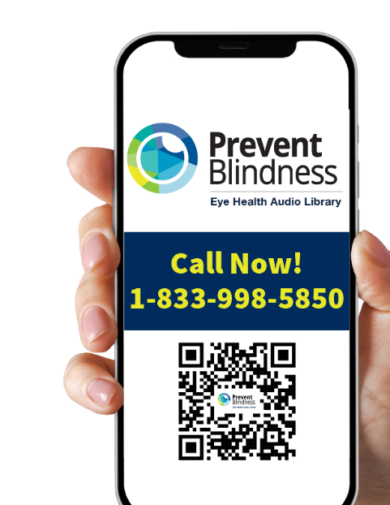
Call Now!
1-833-998-5850

Learn about:
- Protecting your eyesight
- Getting ready for eye exams
- Eye health in pregnancy
- Tips for those newly diagnosed with diabetes

The Eye Health Audio Library
- Free
- For people with diabetes, caregivers & family
- Doctor-approved
- Easy-to-understand
- Available in English and Spanish (Disponible en inglés y español)
- Confidential

What You’ll Find
- Eye Disease Explanations: Clear, doctor-approved information about diabetes-related eye conditions in easy-to-understand language.
- Managing Your Eye Disease: Practical guidance on how to manage your condition and prevent vision loss.
- Eye Exam Information: Learn how to access eye exams and understand what to expect during your visit.
- Pregnancy Eye Care: Special guidance is available for managing diabetes-related eye conditions during pregnancy.
- New Patient Guidance: Step-by-step support for those newly diagnosed with diabetes or eye conditions.

How It Works
- Call Anytime: Dial the phone number 24/7 from any phone.
- Choose Your Language: Select English or Spanish.
- Navigate by Voice: Use simple voice commands to find the information you need.
- Listen & Learn: Access 30-second audio segments with reliable, doctor-approved information.
- Text messaging: Request text messages with the information shared.

For more information, visit: https://preventblindness.org/audio-library-resources/

