Webpage Newsletter Email Text - ENGLISH

Prevent Blindness Eye Health Audio Library

DO YOU KNOW HOW DIABETES CAN AFFECT YOUR EYES?
Free, confidential diabetes-related eye health information available 24/7 by phone in English and Spanish. Vetted by medical experts and carefully reviewed to provide reliable, high-quality information for patients and caregivers.
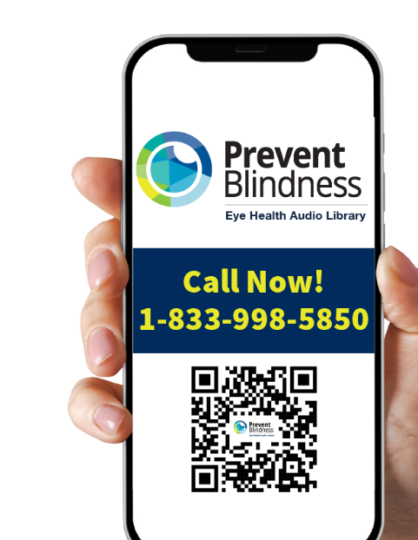

Call Now!
1-833-998-5850

Learn about:
- Protecting your eyesight
- Getting ready for eye exams
- Eye health in pregnancy
- Tips for the newly diagnosed

The Eye Health Audio Library
- Free
- For people with diabetes, caregivers & family
- Doctor-approved
- Easy to understand
- Available in English and Spanish (Disponible en inglés y español)
- Confidential

What You’ll Find
Eye Disease Explanations: Clear, doctor-approved information about diabetes-related eye conditions in easy-to-understand language
Managing Your Eye Disease: Practical guidance on how to manage your condition and prevent vision loss.
Eye Exam Information: Learn how to access eye exams and understand what to expect during your visit.
Pregnancy Eye Care: Special guidance is available for managing diabetes-related eye conditions during pregnancy.
New Patient Guidance: Step-by-step support for those newly diagnosed with diabetes or eye conditions.

How It Works
Call Anytime: Dial the phone number 24/7 from any phone.
Choose Your Language: Select English or Spanish.
Navigate by Voice: Use simple voice commands to find the information you need.
Listen & Learn: Access 30-second audio segments with reliable, doctor-approved information.

For more information visit: https://preventblindness.org/audio-library-resources/

