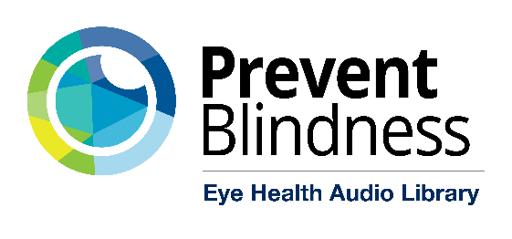

Social Media Sample Posts

LinkedIn Post
A New Resource to Support Patients with Diabetes: Prevent Blindness Eye Health Audio Library

Eye care providers play a key role in helping patients with diabetes protect their vision—even beyond the exam room. The Prevent Blindness Eye Health Audio Library is a free, patient-friendly audio resource, available 24/7, focused on eye health and diabetes-related vision conditions.

This accessible format is ideal for patients who prefer to listen, have low vision, face literacy barriers, or want clear information they can revisit anytime.

✅ Diabetes-focused eye health education
✅ Easy-to-share with patients, care partners, and families
✅ Supports understanding of diabetes-related eye disease and the importance of routine eye exams

We encourage providers to share this trusted resource with patients as part of ongoing diabetes and vision care. Explore and share the Audio Library: https://preventblindness.org/eye-health-audio-library/

#PreventBlindness #DiabetesCare #DiabeticEyeDisease #PatientEducation #EyeHealth #HealthEquity #AccessibleCare

Instagram Post #1
Do you know how diabetes can affect your eyes?
Call the free @prevent_blindness Eye Health Audio Library to learn how to protect your sight and prepare for eye exams - available anytime in English and Spanish!
📞1-833-998-5850
✔ Doctor-approved
✔ Easy-to-understand
✔ Confidential and available 24/7
For people with diabetes, caregivers, and families.
#preventblindness #diabetes #eyehealth

Instagram Post #2
The Prevent Blindness Eye Health Audio Library is Spanish user approved! One listener shared their gratitude for the platform’s simple language, accessibility, and ease of use.
Call today to learn how to protect your sight and prepare for your next eye exam!
📞 1-833-998-5850
✔ Doctor-approved
✔ Easy to understand
✔ Confidential and available 24/7
For people with diabetes, caregivers, and families.
PreventBlindness.org/audio-library
#PreventBlindness #Diabetes #EyeHealth

Facebook Post #1
Do you know how diabetes can affect your eyes?
Call the free @prevent_blindness Eye Health Audio Library to learn how to protect your sight and prepare for eye exams - available anytime in English and Spanish!
1-833-998-5850
Doctor-approved
Easy to understand
Confidential and available 24/7
For people with diabetes, caregivers, and families.
#preventblindness #diabetes #eyehealth
Learn more: PreventBlindness.org/audio-library

Facebook Post #2
The Prevent Blindness Eye Health Audio Library is Spanish user approved! One listener shared their gratitude for the platform’s simple language, accessibility, and ease of use.
Call today to learn how to protect your sight and prepare for your next eye exam!
1-833-998-5850
Doctor-approved
Easy to understand
Confidential and available 24/7
For people with diabetes, caregivers, and families.
PreventBlindness.org/audio-library
#PreventBlindness #Diabetes #EyeHealth

Facebook Post #3
Do you have diabetes? Prevent Blindness has a NEW and FREE eye health resource -PreventBlindness.org/audio-library! 👁️
In this video, research scientist and volunteer at Prevent Blindness, Ricardo Cruz, breaks down how to use the Eye Health Audio Library and describes its easy accessibility!
Just call 1-833-998-5850! 📞
VIDEO LINK: https://youtu.be/aIMW-5kcHB0?si=5KtRmfLdpKkl5fW4

X Post #1
Do you know how diabetes can affect your eyes?

Call the free
@PBA_savingsight
Eye Health Audio Library to learn how to protect your sight and prepare for eye exams - available anytime in English and Spanish!

📞1-833-998-5850
✔ Doctor-approved
✔ Easy to understand
✔ Confidential and available 24/7

For people with diabetes, caregivers, and families.

#preventblindness #diabetes #eyehealth

X Post #2
The Prevent Blindness Eye Health Audio Library is Spanish user approved! One listener shared their gratitude for the platform’s simple language, accessibility, and ease of use.
Call today to learn how to protect your sight and prepare for your next eye exam!
📞 1-833-998-5850
✔ Doctor-approved
✔ Easy to understand
✔ Confidential and available 24/7
For people with diabetes, caregivers, and families.
PreventBlindness.org/audio-library
#PreventBlindness #Diabetes #EyeHealth

X Post #3
Do you have diabetes?
@PBA_savingsight
has a NEW and FREE eye health resource - the Eye Health Audio Library! 👁️

In this video, research scientist and volunteer at Prevent Blindness, Ricardo Cruz, breaks down how to use the resource and describes its easy accessibility!

Just call 1-833-998-5850! 📞
VIDEO LINK: https://youtu.be/aIMW-5kcHB0?si=5KtRmfLdpKkl5fW4

#eyehealth #diabetes #preventblindness

